Viruses
A virus is basically a tiny bundle of genetic material—either DNA or RNA—carried in a shell called the viral coat, or capsid, which is made up of bits of protein. Some viruses have an additional lipid layer around this coat called an envelope. That's basically all there is to viruses. Viruses are not considered to be alive.

Single-Minded Mission Viruses exist for one purpose only: to reproduce. To do that, they have to take over the reproductive machinery of suitable host cells.

Viruses are very SPECIFIC to what type of host cell they infect. For example, the HIV virus that causes AIDS only infects Helper T Cells ( a type of immune cell/white blood cell). This is such a nasty virus because it attacks the type of cell that is responsible for fighting off pathogens (bad stuff, like bacteria and viruses). The spikes on the outside of a virus RECOGNIZE and ATTACH to the RECEPTOR proteins of their specific host cell.

Structure Viruses are very small. (viruses are smaller that prokaryotes, which are smaller than eukaryotes)
Viruses consist of Nucleic Acid (DNA or RNA) and Proteins

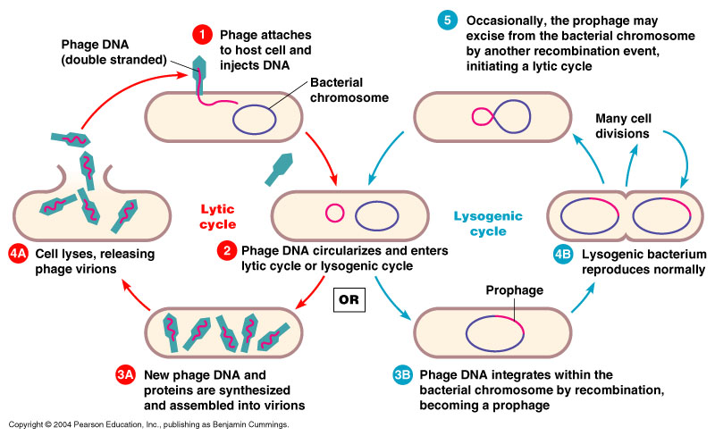
Viruses can undergo 2 cycles:
- Lytic Cycle – The virus injects its DNA into the host cell and hijacks the cell. Many new viruses are produced, which burst out of the cell, killing it and making the host sick.
- Lysogenic Cycle – The virus injects its DNA into the host cell, but the DNA integrates with the host cell’s DNA (goes dormant/hidden). When the cell replicates, the Viral DNA replicates with it. It can then enter the Lytic cycle.

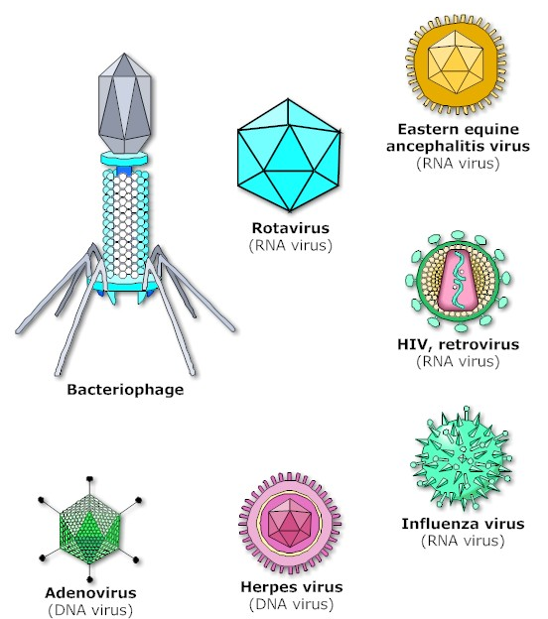

Examples:

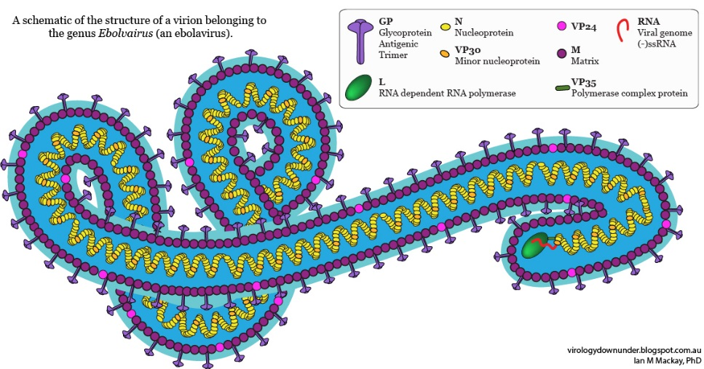
Ebola Virus

Bacteria

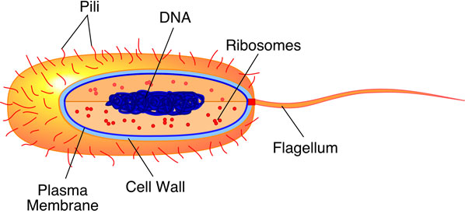
Bacteria are a kingdom of living things that contains prokaryotic cells. Bacteria live almost everywhere on earth, including inside of YOU! As Prokaryotes, they do not have a nucleus or membrane-bound organelles, but they do have DNA and ribosomes. Some bacteria are Pathogens, meaning they can infect other living things and cause illness.
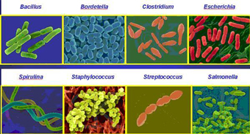
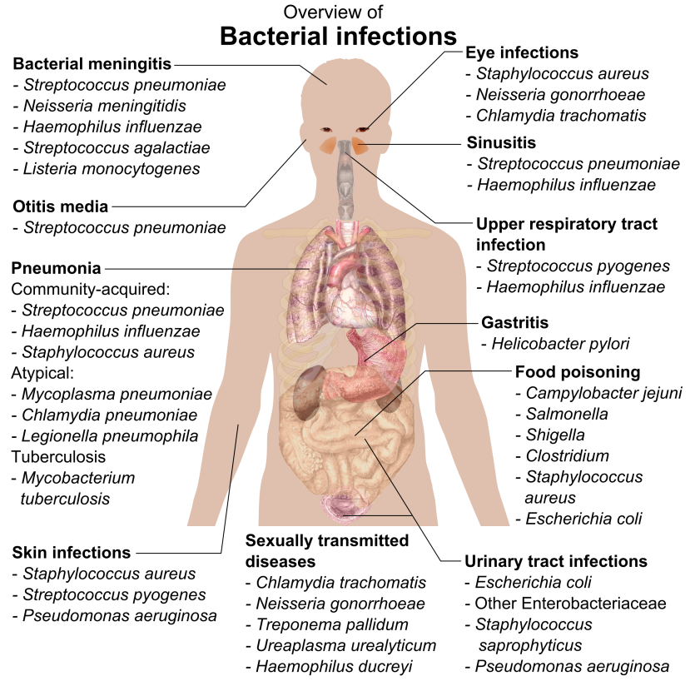
Not all Bacteria are Bad!!

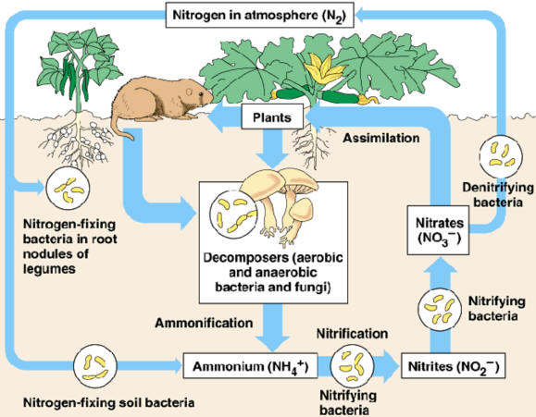
Harmless and beneficial bacteria far outnumber harmful varieties. Thousands of bacterial species live commensally in humans, and many provide health benefits to humans, aiding in digestion, for example, or helping to prevent the establishment of colonies of pathogenic bacteria.
Bacteria play an important role in the Nitrogen Cycle! Nitrogen is needed by plants to make proteins and DNA. (Nitrogen-fixing bacteria turn atmospheric nitrogen into Ammonium and Nitrifying bacteria turn Ammonium into Nitrites/Nitrates that can be incorporated in plants through the soil.)

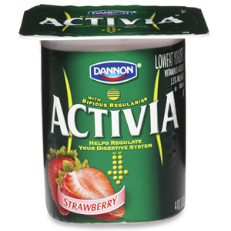
Yogurt contains “Probiotics” which are beneficial bacteria that aid in digestion.

Defense against Pathogens
(Immune system, Vaccinations, Antibiotics, and preventative cleanliness)

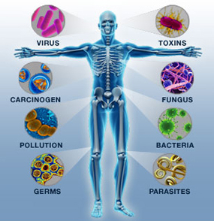
Your Immune System
White blood cells can:
- ingest pathogens and destroy them
- produce antibodies to destroy pathogens
- produce antitoxins that neutralise the toxins released by pathogens
Note:
- the pathogens are not the disease - they cause the disease
- white blood cells do not eat the pathogens - they ingest them
- antibodies and antitoxins are not living things - they are specialised proteins

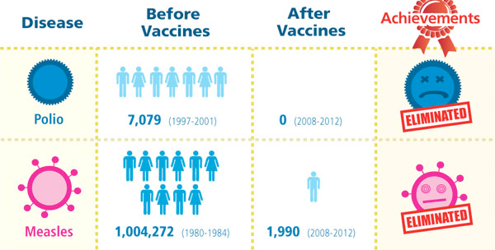
Vaccination
People can be immunised against a pathogen through vaccination. Different vaccines are needed for different pathogens.
- Vaccines work to prime your immune system against future “attacks” by a particular disease. There are vaccines against both viral and bacterial pathogens, or disease-causing agents.
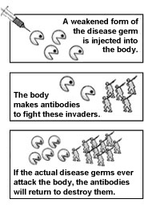
- When a pathogen enters your body, your immune system generates antibodies to try to fight it off. Depending on the strength of your immune response and how effectively the antibodies fight off the pathogen, you may or may not get sick.
- If you do fall ill, however, some of the antibodies that are created will remain in your body playing watchdog after you’re no longer sick. If you’re exposed to the same pathogen in the future, the antibodies will ”recognize” it and fight it off.
- Vaccines work because of this function of the immune system. They’re made from a killed, weakened, or partial version of a pathogen. When you get a vaccine, whatever version of the pathogen it contains isn’t strong or plentiful enough to make you sick, but it’s enough for your immune system to generate antibodies against it. As a result, you gain future immunity against the disease without having gotten sick: if you’re exposed to the pathogen again, your immune system will recognize it and be able to fight it off.

Cleanliness
One simple way to reduce the risk of infection is to maintain personal hygiene and to keep hospitals clean. In the 19th century, Ignaz Semmelweis realised the importance of cleanliness in hospitals. However, although his ideas were successful, they were ignored at the time because people did not know that diseases were caused by pathogens that could be killed.

Antibiotics – defense against Bacterial Pathogens
Antibiotics are substances that kill bacteria or stop their growth. They do not work against viruses: it is difficult to develop drugs that kill viruses without also damaging the body’s tissues.

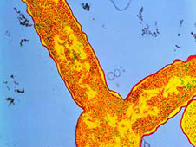
Penicillin
A bacterium damaged and distorted by penicillin
The first antibiotic - penicillin - was discovered in 1928 by Alexander Fleming. He noticed that some bacteria he had left in a petri dish had been killed by naturally occurring penicillium mold.
Since the discovery of penicillin, many other antibiotics have been discovered or developed. Most antibiotics used in medicine have been altered chemically to make them more effective and safer for humans.
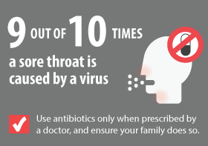
Resistance
Bacterial strains can develop resistance to antibiotics. This happens because of natural selection. In a large population of bacteria, there may be some cells that are not affected by the antibiotic. These cells survive and reproduce, producing even more bacteria that are not affected by the antibiotic.
MRSA is methicillin-resistant staphylococcus aureus. It is very dangerous because it is resistant to most antibiotics. It is important to avoid over-use of antibiotics, so we can slow down, or stop, the development of other strains of resistant bacteria.
Resistance to antibiotics, is coded for by small rings of DNA found in bacteria, called plasmids.
Some bacteria may contain up to five plasmids, each conferring resistance to a different antibiotic. DNA and therefore plasmids can be passed between members of the same species of bacteria during conjugation, or sexual reproduction. Specialised tubes or pili join one bacterium to another during conjugation.
Resistance to antibiotics is increasing and has a great impact on the treatment of a disease because it prolongs illness and increases mortality. Hospitals try and keep some antibiotics as a last resort and drug companies are continually looking for new ones.
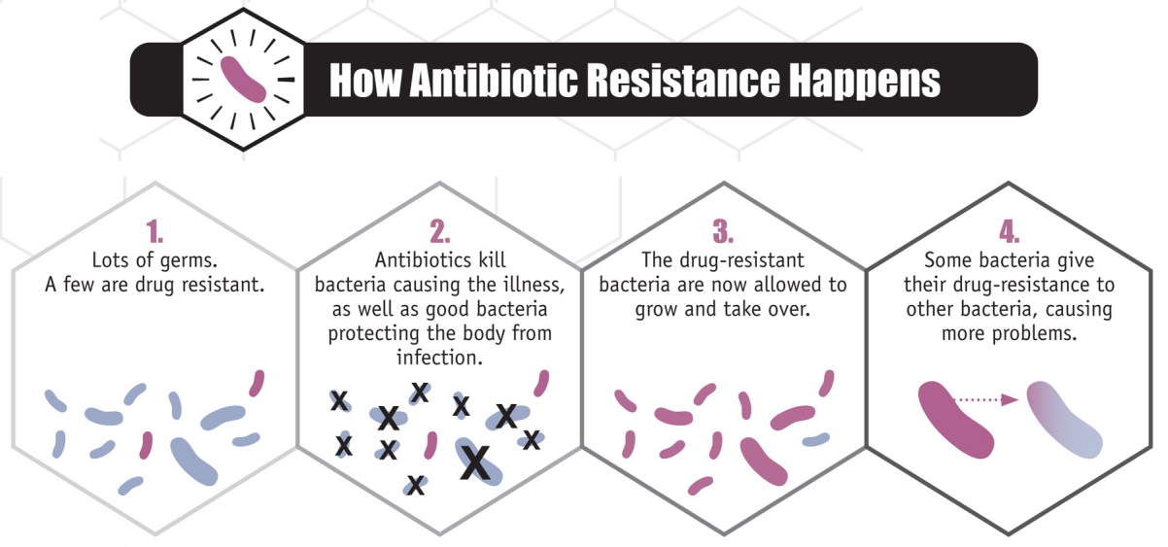

What is a Pathogen?
Pathogens cause disease. A pathogen (disease-causing agent) is a microorganism that causes disease in its host (human, animals, plant, another microorganism)
Pathogens include bacteria, viruses, fungi, protozoa, and a newly discovered class of pathogens prions.
Pathogens invade from outside the body and there are several substrates and pathways wherein they invade a host. As a group they are accounted for a large portion of human diseases.
BACTERIA: Though most bacteria are harmless and beneficial, few bacteria are pathogens. These single-celled living organisms are dependent on living human cells for their energy supply. Thus they damage or kill the human cells and cause diseases like TONSILLITIS, PNEUMONIA, BOTULISM, SYPHILIS etc. Bacterial infections are often treated with antibiotics.
VIRUSES: Viruses are tiny infectious agents consisting of a small piece of genetic material either RNA or DNA and surrounded by a protein coat. They are acellular microorganisms (not composed of cells)
As they gain entry into living host cells the viral genetic material (DNA or RNA) enters the cell. Their protein coats are dissolved to incorporate the already released viral genetic material into the cell's genetic material. Some viruses release their genetic contents into the cells cytoplasm by merging their outer coat with the cell membrane.
Viruses cause diseases such as AIDS, HEPATITIS, CHICKEN POX, ENCEPHALITIS, COLDS, FLU, MEASLES, RABIES, POLIO etc.
PRIONS: Prions refers to infectious proteins. Prion is an entirely new class of infectious pathogen. Caused by proteinaceous infectious particles, a common feature of this disease is the presence of unusual accumulations of misfolded proteins in our nerve cells, as they chock-off nerve cell functions. In other words the 'rogue proteins' refold normal prion proteins into the new shape causing the normal prion protein to lose its original function.
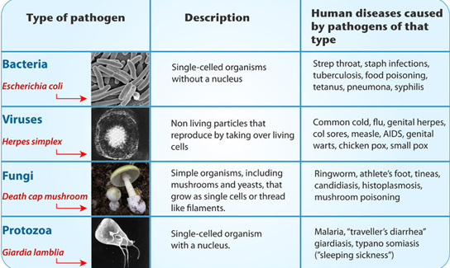
Why do we get sick?
Pathogenic microbes challenge the immune system in many ways. Viruses make us sick by killing cells or disrupting cell function. Our bodies often respond with fever (heat inactivates many viruses), the secretion of a chemical called interferon (which blocks viruses from reproducing), or by marshaling the immune system’s antibodies and other cells to target the invader. Many bacteria make us sick the same way, but they also have other strategies at their disposal. Sometimes bacteria multiply so rapidly they crowd out host tissues and disrupt normal function. Sometimes they kill cells and tissues outright. Sometimes they make toxins that can paralyze, destroy cells’ metabolic machinery, or precipitate a massive immune reaction that is itself toxic.

Extension (go and explore this website on your tablet)
http://webecoist.momtastic.com/2011/09/26/beneficial-bacteria-12-ways-microbes-help-the-environment/

