PART 1: LABEL THE CELL CYCLE DIAGRAM

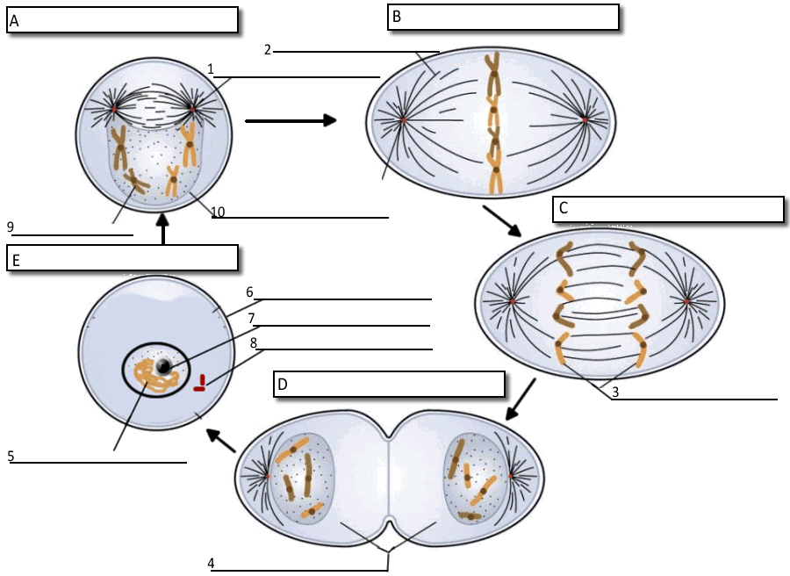

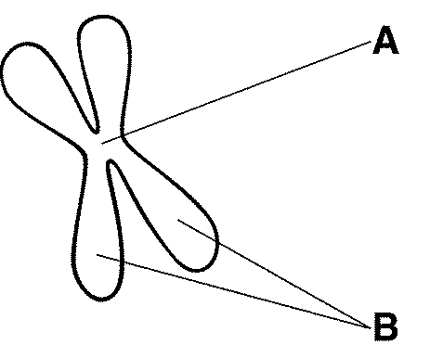
Figure 10–2

11. The structure labeled A in Figure 10–2 is called the __________________________
12. The structures labeled B in Figure 10–2 are called ___________________________
PART 2: MITOSIS
Label the picture below to identify the phases of mitosis. Use these choices:
anaphase metaphase prophase telophase
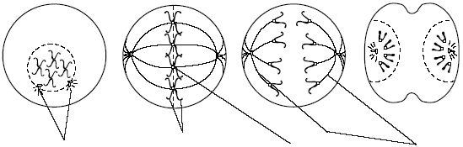  1. | 2. | 3. _ | 4.
5 | 6 | 7 |  | 8
Label the cell parts indicated above, using these choices:
sister chromatids centromere spindle fibers centrioles

PART 3: INTERPHASE VS MITOSIS
For each of the actions below, tell if it occurs during interphase or some phase of mitosis.
I. Interphase M. Mitosis
9. Cell growth occurs.
10 Nuclear division occurs.
11. Chromosomes are distributed equally to daughter cells.
12. Protein production is high.
13. Chromosomes are duplicated.
14. DNA synthesis occurs.
15. Cytoplasm divides immediately after this period.
16. Mitochondria and other organelles are manufactured.
17. DNA may be miscopied resulting in cell changes leading to cancerous cell division

PART 4: Draw the chromosomes in the cell as it undergoes MEIOSIS:
Prophase I Metaphase I Anaphase I Telophase I
Anaphase II Metaphase II Prophase II
Daughter Cells
Telophase II

Write the correct Meiotic Phase next to the description:

1. ________________ homologous chromosome line up in the center of the cell
2. _________________ spindle fibers pull homologous pairs to ends of the cell
3. ________________ 4 haploid (N) daughter cells form\
4. ________________ cells undergo a round of DNA replication
5. _________________ sister chromatids separate from each other
6. ________________ 2 haploid (N) daughter cells form
7. _________________ spindle fibers attach to the homologous chromosome pairs
8. ________________ individual chromatids move to each end of the cell
9. _________________ crossing‐over (if any) occurs

PART 5: Create a Venn Diagram to Compare and Contrast Mitosis and Meiosis
~Use the following terms or phrases:

produces haploid cells produces 4 cells

occurs in germ cells (produces sex cells) DNA is copied once

occurs in plant and animal cells involves cellular division

In humans, produces cells with 23 cell divides only once
Chromosomes

homologous chromosomes line up during Metaphase produces 2 cells

new cells are different from each other
has 2 divisions

In humans, produces cells with 46 occurs in body (somatic) cells
Chromosomes

Does not involve lining up of homologous crossing over occurs, creating new
Chromosomes genetic combinations in offspring

PART 6: FILL IN THE BLANK
Use each of the terms below just once to complete the passage:
nucleus genetic material chromosomes packed
identical chromatin vanish cell division
The process by which two cells are produced from one cell is called (18)_______________. The two cells are (19)__________________ to the original cell. Early biologists observed that just before cell division, several short, stringy structures appeared in the (20)______________ .These structures seemed to (21)____________________ soon after cell division. These structures, which contain DNA and became darkly colored when stained, are now called (22)______________________ . Scientists eventually learned that chromosomes carry (23)______________________ , which is copied and passed on from generation to generation. Chromosomes normally exist as (24)______________________ , long strands of DNA wrapped around proteins. However, before a cell divides, the chromatin becomes tightly (25)______________________ .

PART 7: MULTIPLE CHOICE

______ 1. As a cell becomes larger, its
a. | volume increases faster than its surface area.
b. | surface area increases faster than its volume.
c. | volume increases, but its surface area stays the same.
d. | surface area stays the same, but its volume increases.

____ 2. Which of the following is a correct statement about the events of the cell cycle?
a. | Little happens during the G₁ and G₂ phases.
b. | DNA replicates during cytokinesis.
c. | The M phase is usually the longest phase.
d. | Interphase consists of the G₁, S, and G₂ phases.

____ 3. What is the role of the spindle during mitosis?
a. | It helps separate the chromosomes.
b. | It breaks down the nuclear membrane.
c. | It duplicates the DNA.
d. | It divides the cell in half.

____ 4. Cancer is a disorder in which some cells have lost the ability to control their
a. | size. C. growth rate
b. | spindle fibers. D. surface area

____ 5. If an organism’s diploid number is 12, its haploid number is
a. | 12. c. 24
b. | 6. d. 3

____ 6. Gametes have
a. | homologous chromosomes.
b. | twice the number of chromosomes found in body cells.
c. | two sets of chromosomes.
d. | one allele for each gene.

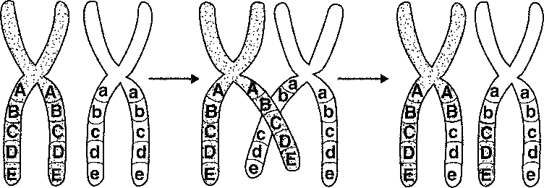

____ 7. What is shown in the figure above?
a. | independent assortment c. crossing over
b. | anaphase I of meiosis d. replication

____ 8. Unlike mitosis, meiosis results in the formation of
a. | diploid cells. C. 2N daughter cells
b. | haploid cells. D. body cells

____ 9. Unlike mitosis, meiosis results in the formation of
a. | two genetically identical cells. C. four genetically identical cells
b. | four genetically different cells. D. two genetically different cells

______10. Which pair is correct?
a. G₁ phase, DNA replication
b. G₂ phase, preparation for mitosis
c. S phase, cell division
d. M phase, cell growth

Don’t Forget to Study!

