The Cell Cycle
No matter where you live, you have probably noticed that the weather changes in a regular pattern each year. Some areas have four seasons—winter, spring, summer, and fall. As seasons change, temperature, precipitation, and the number of hours of sunlight change in a regular cycle. Cells also go through cycles, just like the seasons. Most cells in an organism go through a cycle of growth, development, and division called the cell cycle. The cell cycle makes it possible for organisms
• to grow and develop,
• to replace cells that are old or damaged, and
• to produce new cells.
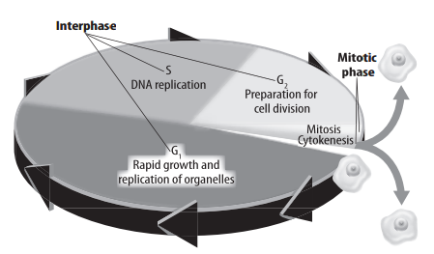
Phases of the Cell Cycle
There are two main phases in the cell cycle. These phases are interphase and the mitotic phase. Interphase is the period of a cell’s growth and development. A cell spends most of its life in interphase.
Most cells go through three stages during interphase:
• rapid growth and replication, or copying, of the membrane-bound structures called organelles,
• copying of DNA, the genetic information in a cell, and
• preparation for cell division.
Interphase is followed by a shorter phase of the cell cycle called the mitotic phase.
A cell reproduces during the mitotic phase. The mitotic phase has two stages, as shown in the figure below. During the first stage, the contents of the nucleus divide. During the second stage, the cell’s fluid, or cytoplasm, divides. The mitotic phase creates two new identical cells. The original cell no longer exists.
Length of a Cell Cycle
The time it takes a cell to complete the cell cycle depends on the type of cell that is dividing. Recall that a eukaryotic cell has membrane-bound organelles, including a nucleus. The cell cycle for some eukaryotic cells might only take eight minutes. The cell cycle for other eukaryotic cells might take up to one year. Most of the cells in the human body can complete the cell cycle in about 24 hours. The cells of some organisms divide very quickly. For example, the fertilized egg of the zebra fish divides into 256 cells in 2.5 hours.

Interphase
A new cell begins interphase with a period of rapid growth, in which the cell gets bigger. Cellular activities, such as making proteins, follow. Each cell that is actively dividing copies its DNA and prepares for cell division. A cell’s DNA is called chromatin during interphase. Chromatin is long, thin strands of DNA in the nucleus. If scientists add dye to a cell in interphase, the nucleus looks like a plate of spaghetti. This is because the nucleus contains strands of chromatin tangled together.
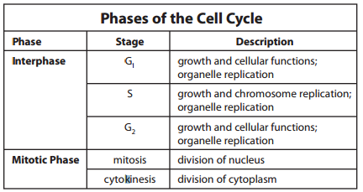
Phases of Interphase
Interphase can be divided into three different stages, as shown in the table below.
The G₁ Stage The first stage of interphase is the G₁ stage. This is a period of rapid growth. G₁ is the longest stage of the cell cycle. During G₁, a cell grows and carries out its normal cell functions. For example, during G₁ the cells that line your stomach make enzymes that help you digest your food. Most cells continue the cell cycle. However, some cells stop the cell cycle at the G₁ stage. Mature nerve cells in your brain remain in G₁ and do not divide again.
The S Stage The second stage of interphase is the S stage. During the S stage, a cell grows and copies its DNA. Strands of chromatin are copied, so there are now two identical strands of DNA. This is necessary because each new cell gets a copy of the genetic information. The new strands coil up and form chromosomes. A cell’s DNA is arranged as pairs. Each pair is called a duplicated chromosome. Two identical chromosomes called sister chromatids make up a duplicated chromosome. The sister chromatids are held together by a structure called a centromere.
The G₂ Stage The last stage of interphase is the G₂ stage. This is another period of growth and the final preparation for mitosis. A cell uses energy to copy DNA during the S stage. During G₂, the cell stores energy that will be used during the mitotic phase of the cell cycle.
Organelle Replication During cell division, the organelles are distributed between the two new cells. Before a cell divides, it makes a copy of each organelle. This way, the two new cells can function properly. Some organelles, such as the energy processing mitochondria and chloroplasts, have their own DNA. These organelles can make copies of themselves on their own. A cell produces other organelles from materials such as proteins and lipids. A cell makes these materials using the information in the DNA inside the nucleus. Organelles are copied during all stages of interphase.

The Mitotic Phase
The mitotic phase of the cell cycle follows interphase. There are two stages of the mitotic phase: mitosis and cytokinesis. In mitosis, the nucleus and its contents divide. In cytokinesis, the cytoplasm and its contents divide. Daughter cells are the two new cells that result from mitosis and cytokinesis.
During mitosis, the contents of the nucleus divide, forming two identical nuclei. The sister chromatids of the duplicated chromosomes separate from each other. This gives each daughter cell the same genetic information. For example, a cell that has ten duplicated chromosomes actually has 20 chromatids. When the cell divides, each daughter cell will have ten different chromatids. Chromatids are now called chromosomes. During cytokinesis, the cytoplasm divides and two new daughter cells form. The organelles that were made during interphase are divided between the daughter cells.
Phases of Mitosis
Prophase During the first phase of mitosis, called prophase, the copied chromatin coils together tightly. The coils form duplicated chromosomes that can be seen with a microscope. The nucleolus disappears and the nuclear membrane breaks down. Structures called spindle fibers form in the cytoplasm.
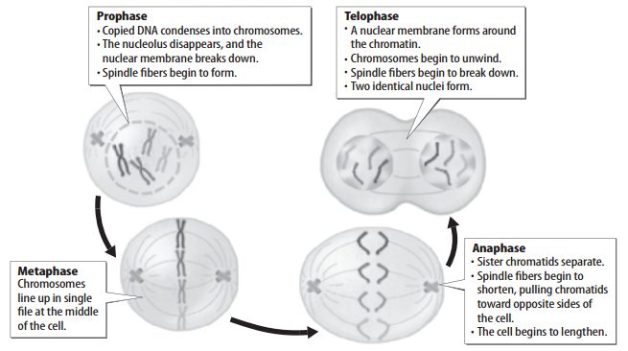
Metaphase The spindle fibers pull and push the duplicated chromosomes to the middle of the cell during metaphase. Notice in the figure above that the chromosomes line up along the middle of the cell. This makes sure that each new cell will receive one copy of each chromosome. Metaphase is the shortest phase in mitosis. It is an important phase because it makes the new cells the same.

Anaphase In anaphase, the two sister chromatids separate from each other and are pulled in opposite directions. Once they are separated, the chromatids are now two identical single-stranded chromosomes. As the single-stranded chromosomes move to opposite sides of the cell, the cell begins to get longer. Anaphase ends when the two sets of identical chromosomes reach opposite ends of the cell.
Telophase During telophase, the spindle fibers that helped divide chromosomes begin to disappear. The chromosomes begin to uncoil. A nuclear membrane grows around each set of chromosomes at either end of the cell. Two new identical nuclei form.
Dividing the Cell’s Components
After the last phase of mitosis, the cytoplasm of a cell divides in a process called cytokinesis. The specific steps of cytokinesis depend on the type of cell that is dividing. In an animal cell, the cell membrane contracts, or squeezes together, around the middle of the cell. Fibers around the center of the cell pull together. This forms a crease, called a furrow, in the middle of the cell. This furrow gets deeper and deeper until the cell membrane comes together and divides the cell.
Cytokinesis in plant cells is different. A new cell wall forms in the middle of a plant cell. Organelles called vesicles join together to form a membrane-bound disk called a cell plate. The cell plate then grows outward toward the cell wall until two new cells form.
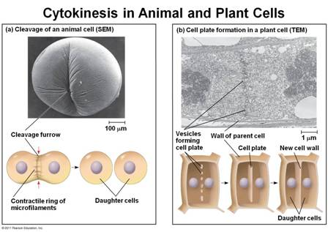

Results of Cell Division
The cell cycle results in two new cells. These daughter cells are genetically the same. They also are the same as the original cell that no longer exists. A human cell has 46 chromosomes. When that cell divides, it produces two new cells, each with 46 chromosomes. The cell cycle is important for reproduction in some organisms. It is important for growth in multicellular organisms. The cell cycle also helps replace worn-out or damaged cells and repair damaged tissues.
Reproduction Cell division is a form of reproduction for some unicellular organisms. For example, an organism called a paramecium reproduces by dividing into two new daughter cells, or two new paramecia. Cell division is also important in other methods of reproduction in which the offspring are identical to the parent organism.
Growth Cell division allows multicellular organisms, such as humans, to grow and develop from one cell (a fertilized egg). In humans, cell division begins about 24 hours after fertilization. Cell division continues quickly for the first few years of life. During the next few years, you will probably go through a period of rapid growth and development. This happens because cells divide and increase in number as you grow and develop.
Replacement Cell division continues even after an organism is fully grown. Cell division replaces cells that wear out or are damaged. The outermost layer of your skin is always rubbing or flaking off. A layer of cells below the skin’s surface is constantly dividing. This produces millions of new cells each day to replace the ones that rub off.
Repair Cell division is also important for repairing damage. When a bone breaks, cell division produces new bone cells. These new cells patch the broken pieces of bone back together. Not all damage can be repaired. This is because not all cells continue to divide. Some nerve cells stop the cell cycle in interphase. Injuries to nerve cells often cause permanent damage.
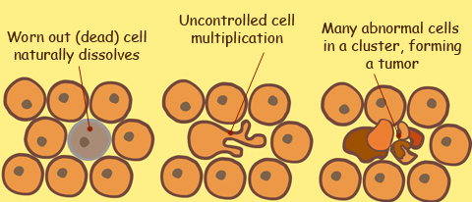
Cancer The cell cycle is tightly controlled and new cells are only created if the body needs to replace worn out cells. When cells continue multiplying although the body doesn't need them, the result is an extra mass or growth, also called a tumor. This uncontrolled cell growth is commonly known as cancer.

Illustration of uncontrolled multiplication of abnormal cells

